# OUTPUTS:-

1. EXERCISE 1-IMPLEMENTING SINGLETON PATTERN

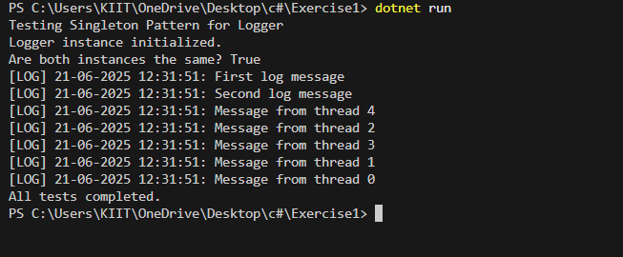

1. Exercise 2: Implementing the Factory Method Pattern

